The Nervous System

Functions of the Nervous System

- Gathers information from both inside and outside the body - Sensory Function
- Transmits information to the processing areas of the brain and spine
- Processes the information in the brain and spine – Integration Function
- Sends information to the muscles, glands, and organs so they can respond appropriately – Motor Function

It controls and coordinates all essential functions of the body including all other body systems allowing the body to maintain homeostasis or its delicate balance.

The Nervous System is divided into Two Main Divisions: Central Nervous System (CNS) and the Peripheral Nervous System (PNS)

Divisions of the Nervous System
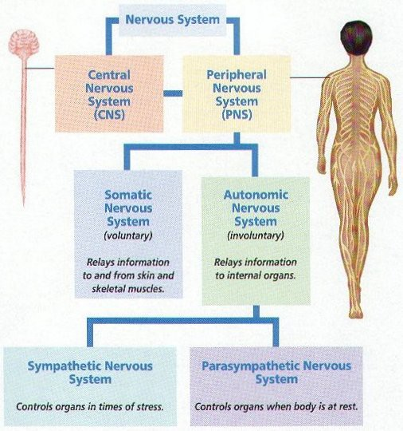

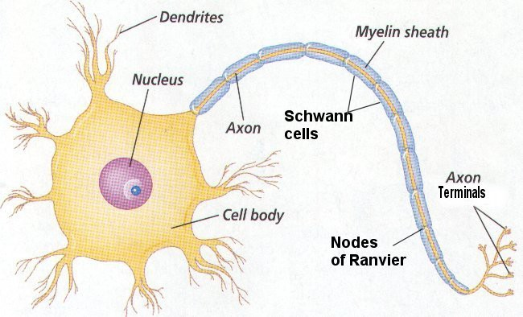
Basic Cells of the Nervous System

Neuron
- Basic functional cell of nervous system
- Transmits impulses (up to 250 mph)

Parts of a Neuron
- Dendrite – receive stimulus and carries it impulses toward the cell body
- Cell Body with nucleus – nucleus & most of cytoplasm
- Axon – fiber which carries impulses away from cell body
- Schwann Cells- cells which produce myelin or fat layer in the Peripheral Nervous System
- Myelin sheath – dense lipid layer which insulates the axon – makes the axon look gray
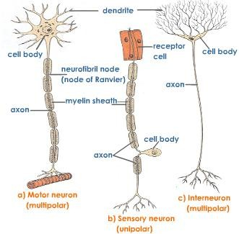
- Node of Ranvier – gaps or nodes in the myelin sheath
- Impulses travel from dendrite to cell body to axon

Three types of Neurons

  - Sensory neurons – bring messages to CNS
  - Motor neurons - carry messages from CNS
  - Interneurons – between sensory & motor neurons in the CNS

Impulses
- A stimulus is a change in the environment with sufficient strength to initiate a response.
- Excitability is the ability of a neuron to respond to the stimulus and convert it into a nerve impulse
- All of Nothing Rule – The stimulus is either strong enough to start and impulse or nothing happens
- Impulses are always the same strength along a given neuron and they are self-propagation – once it starts it continues to the end of the neuron in only one direction- from dendrite to cell body to axon
- The nerve impulse causes a movement of ions across the cell membrane of the nerve cell.

Synapse
  - Synapse - small gap or space between the axon of one neuron and the dendrite of another - the neurons do not actually tough at the synapse
  - It is junction between neurons which uses neurotransmitters to start the impulse in the second neuron or an effector (muscle or gland)
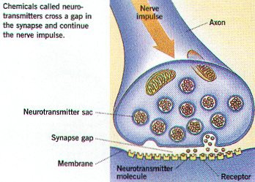
  - The synapse insures one-way transmission of impulses

Neurotransmitters

Neurotransmitters – Chemicals in the junction which allow impulses to be started in the second neuron

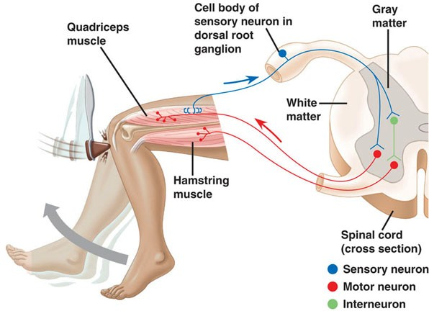
Reflex Arc

Components of a Reflex Arc

- Receptor - reacts to a stimulus
- Afferent pathway (sensory neuron) - conducts impulses to the CNS
- Interneuron - consists of one or more synapses in the CNS (most are in the spine)
- Efferent pathway (motor neuron) conducts impulses from CNS to effector.
- Effector - muscle fibers (as in the Hamstring muscle) or glands responds by contracting or secreting a product.

Spinal reflexes - initiated and completed at the spinal cord level. Occur without the involvement of higher brain centers.

Central Nervous System
  - Brain
    - Brain stem – medulla, pons, midbrain
    - Diencephalon – thalamus & hypothalamus
    - Cerebellem
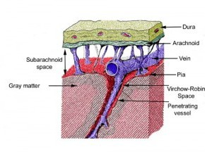
    - Cerebrum
  - Spine
    - Spinal Cord

Meninges
Meninges are the three coverings around the brain & spine and help cushion, protect, and nourish the brain and spinal cord.
- dura mater is the most outer layer, very tough
- arachnoid mater is the middle layer and adheres to the dura mater and has weblike attachments to the innermost layer, the pia mater
- pia mater is very thin, transparent, but tough, and covers the entire brain,
following it into all its crevices (sulci) and spinal cord
- cerebrospinal fluid, which buffers, nourishes, and detoxifies the brain and spinal cord, flows through the subarachnoid space, between the arachnoid mater and the pia mater

Regions of the Brain

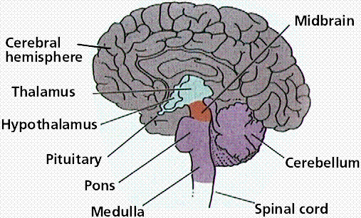
Cerebellum – coordination of movement and aspects of motor learning
Cerebrum – conscious activity including perception, emotion, thought, and planning Thalamus – Brain’s switchboard – filters and then relays information to various brain regions
Medulla – vital reflexes as heart beat and respiration Brainstem – medulla, pons, and midbrain (involuntary responses) and relays information from spine to upper brain
Hypothalamus– involved in regulating activities internal organs, monitoring information from the
autonomic nervous system, controlling the pituitary gland and its hormones, and regulating sleep and appetite

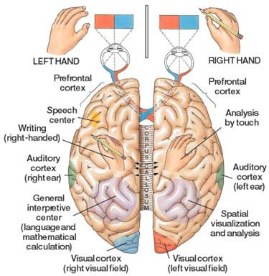
Cerebrum

- Is the largest portion of the brain encompasses about two-thirds of the brain mass -
- It consists of two hemispheres divided by a fissure – corpus callosum
- It includes the cerebral cortex, the medullary body, and basal ganglia
- cerebral cortex is the layer of the brain often referred to as gray matter because it has cell bodies and synapses but no myelin
  - The cortex (thin layer of tissue) is gray because nerves in this area lack the insulation or white fatty myelin sheath that makes most other parts of the brain appear to be white.
  - The cortex covers the outer portion (1.5mm to 5mm) of the cerebrum and cerebellum
  - The cortex consists of folded bulges called
gyri that create deep furrows or fissures called sulci
  - The folds in the brain add to its surface area which increases the amount of gray matter and the quantity of information that can be processed
- Medullary body – is the white matter of the cerebrum and consists of myelinated axons
  - Commisural fibers – conduct impulses between the hemispheres and form corpus callosum
  - Projection fibers – conduct impulse in and out of the cerebral hemispheres
  - Association fibers – conduct impulses within the hemispheres
- Basal ganglia – masses of gray matter in each hemisphere which are involved in the control of voluntary muscle movements

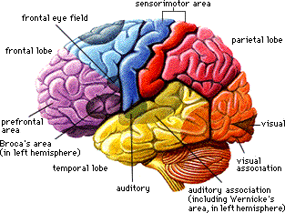
Lobes of the Cerebrum

- Frontal – motor area involved in movement and in planning & coordinating behavior
- Parietal – sensory processing, attention, and language
- Temporal – auditory perception, speech, and complex visual perceptions
- Occipital – visual center – plays a role in processing visual information

Special regions
- Broca’s area – located in the frontal lobe – important in the production of speech
- Wernicke’s area – comprehension of language and the production of meaningful speech
- Limbic System – a group of brain structures (aamygdala, hippocampus, septum, basal ganglia, and others) that help regulate the expression of emotions and emotional memory

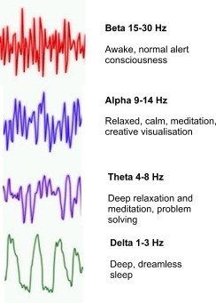
Brain Waves

Brain waves are rhythmic fluctuation of electric potential between parts of the brain as seen on an electroencephalogram (EEG).

  - To measure brain waves electrodes are placed onto the scalp using the EEG.
  - There are four types of brainwaves:

    - Beta
    - Alpha
    - Theta
    - Delta

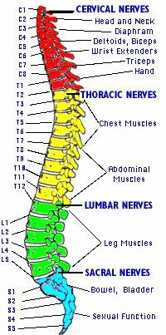
Peripheral Nervous System

Cranial nerves
- 12 pair
- Attached to undersurface of brain

Spinal nerves
- 31 pair
- Attached to spinal cord

Somatic Nervous System (voluntary)
- Relays information from skin, sense organs & skeletal muscles to CNS
- Brings responses back to skeletal muscles for voluntary responses

Autonomic Nervous System (involuntary)
- Regulates bodies involuntary responses
- Relays information to internal organs
- Two divisions
  - Sympathetic nervous system – in times of stress
    - Emergency response
    - Fight or flight
  - Parasympathetic nervous system – when body is at rest or with normal functions
    - Normal everyday conditions

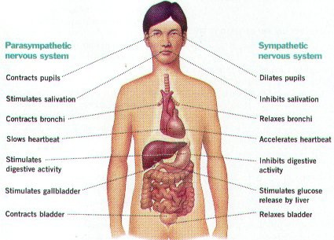

Major Sense Organs

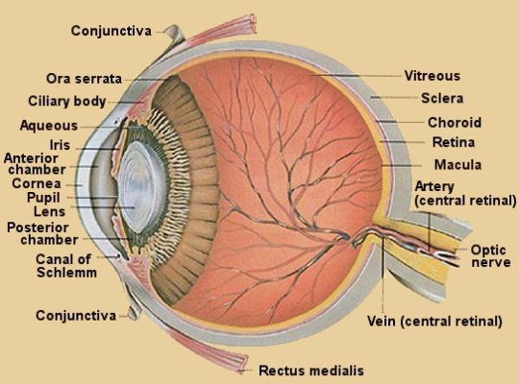
Sensation and perception
  - Vision – Eye
  - Hearing – Ear
  - Taste – Taste receptors (new)
  - Smell – Olfactory system
  - Skin – Hot, cold, pressure, pain

Sense Organs

Eye – the organ used to sense light

Three layers –
- Outer layer consists of sclera and cornea
- Middle layer consists of choroid, ciliary body and iris
- Inner layer consists of retina

Functions of the major parts of the eye:

Sclera or Scleroid Layer – (white of eye) a tough protective layer of connective tissue that helps maintain the shape of the eye and provides an attachment for the muscles that move the eye
Cornea - the clear, dome-shaped part of the sclera covering the front of the eye through which light enters the eye
Anterior Chamber – a small chamber between the cornea and the pupil
Aqueous Humor - the clear fluid that fills that anterior chamber of the eye and helps to maintain the shape of the cornea providing most of the nutrients for the lens and the cornea and involved in waste management in the front of the eye
Choroid Layer - middle layer of the eye containing may blood vessels
Ciliary Body - the ciliary body is a circular band of muscle that is connected and sits immediately behind the iris- produces aqueous humor, changes shape of lens for focusing, and
Iris - the pigmented front portion of the choroid layer and contains the blood vessels - it determines the eye color and it controls the amount of light that enters the eye by changing the size of the pupil (an albino only has the blood vessels – not pigment so it appears red or pink because of the blood vessels)
Lens - a crystalline structure located just behind the iris - it focuses light onto the retina
Pupil - the opening in the center of the iris- it changes size as the amount of light changes (the more light, the smaller the hole)
Vitreous - a thick, transparent liquid that fills the center of the eye - it is mostly water and gives the eye its form and shape (also called the vitreous humor)
Retina - sensory tissue that lines the back of the eye. It contains millions of photoreceptors (rods for black & white and cones for color ) that convert light rays into electrical impulses that are relayed to the brain via the optic nerve
Optic nerve - the nerve that transmits electrical impulses from the retina to the brain
Common eye defects include – myopia or nearsightedness where the eyeball is too long or the cornea is too steep; hyperopia or far sightedness where the eyeball is short or lens cannot become round enough: cataracts where the lens becomes fogged; presbyopia where the muscles controlling the bulging of the lens become weak as we age; nyctalopia or night blindness where vision is impaired in dim light and in the dark due to pigment rhodospin in the rods not functioning properly

Images
  - the cornea and the lens help to produce the image on the retina
  - images formed by the lens are upside down and backwards when they reach the retina
  - two types of receptors on the retina
  - Rods – 125 million on a single retina – extremely sensitive to all wavelengths of visible light but do not distinguish different color – in dim light only rods are activated where one can see objects but not as sharp images and are not able to distinguish their color – most dense in peripheral view – nighttime vision Rods have a pigment called rhodospin
  - As amount of light increases, the cones – 7 million on a single retina – mainly in central view are stimulated and the color becomes clear – daytime vision
  - There are three types of cones which distinguish the three colors – blue, red, green
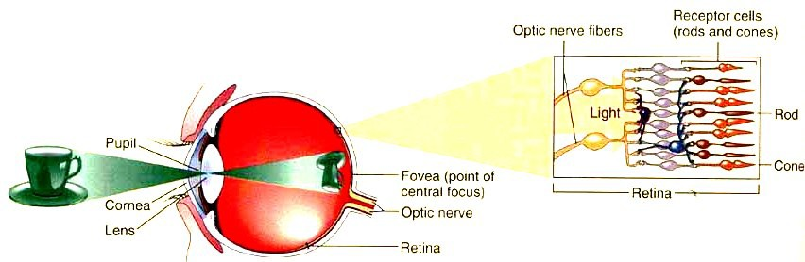
  - Fovea – point of central focus – great density of cones - center of the eye's sharpest vision and the location of most color perception - the layers of the retina spread aside to let light fall directly on the
cones

  - Light stimulates rods and cones and sends impulse via optic nerve to brain areas for vision
  - The Optic Nerve exits the eye just off center near the Fovea - the Optic Nerve exits is referred to as the Blind Spot due to the lack of the receptors in this area
  - The two Optic Nerves come together at the Optic Chiasm located just under the hypothalamus - a crucial part of vision and perception must happen - cross-over of information from the right eye crosses over to the left side and visa versa happens here at the Optic Chiasm
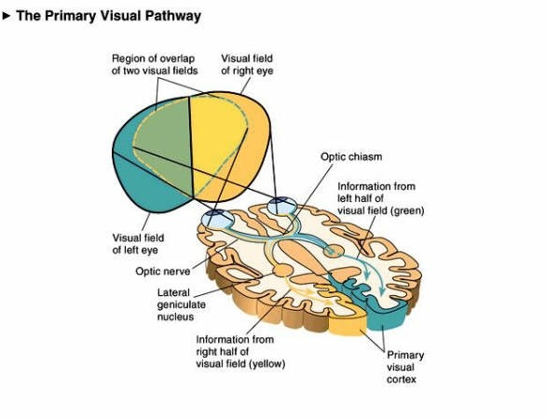
  - Information from each eye must be processed in both halves of the brain
  - Information leaves the chiasm via the optic tract.
  - Reorganized optic tract leaves the Optic Chiasm and passes onto the lateral geniculate nucleus
  - At the lateral geniculate nuclei the information is separated, organized, and relayed to different areas of the visual cortex
  - The different zones of the visual cortex process the different aspects of vision and information, taken from both visual fields, is processed and an image is perceived
.

EAR

Outer Ear & ear canal – brings sound into eardrum
Eardrum – vibrates to amplify sound & separates inner and middle ear
Middle ear has 3 small bones or Ossicles = anvil, stirrup, stapes – amplify sound (small bones) which vibrate sound
Eustachian tube – connects middle ear to throat and equalizes pressure on eardrum
Cochlea – in inner ear – has receptors for sound & sends signals to brain via Auditory Nerve

Process of hearing:
- Sound waves enter your outer ear and travel through your ear canal to the middle ear.
- The ear canal channels the waves to your eardrum, a thin, sensitive membrane stretched tightly over the entrance to your middle ear.
- The waves cause your eardrum to vibrate.
- It passes these vibrations on to the hammer, one of three tiny bones in your ear. The hammer vibrating causes the anvil, the small bone touching the hammer, to vibrate. The anvil passes these vibrations to the stirrup, another small bone which touches the anvil. From the stirrup, the vibrations pass into the inner ear.
- The stirrup touches a liquid filled sack and the vibrations travel into the cochlea, which is shaped like a shell.
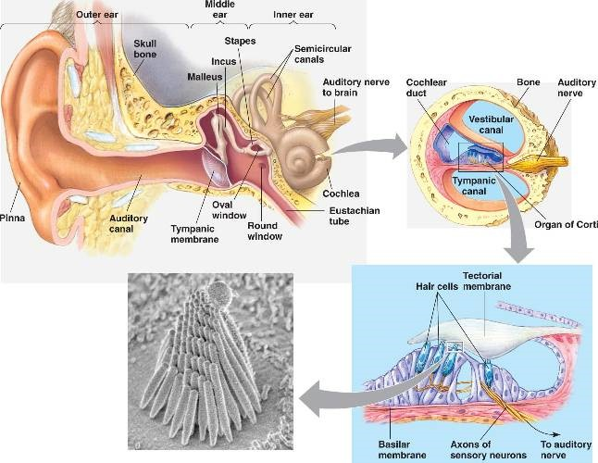
- Inside the cochlea, a vestibular system formed by three semicircular canals that are approximately at right angles to each other and which are responsible for the sense of balance and spatial orientation. It has chambers filled with a viscous fluid and small particles (otoliths) containing calcium carbonate. The movement of these particles over small hair cells in the inner ear sends signals to the brain that are interpreted as motion and acceleration. The brain processes the information from the ear and lets us distinguish between different types of sounds.

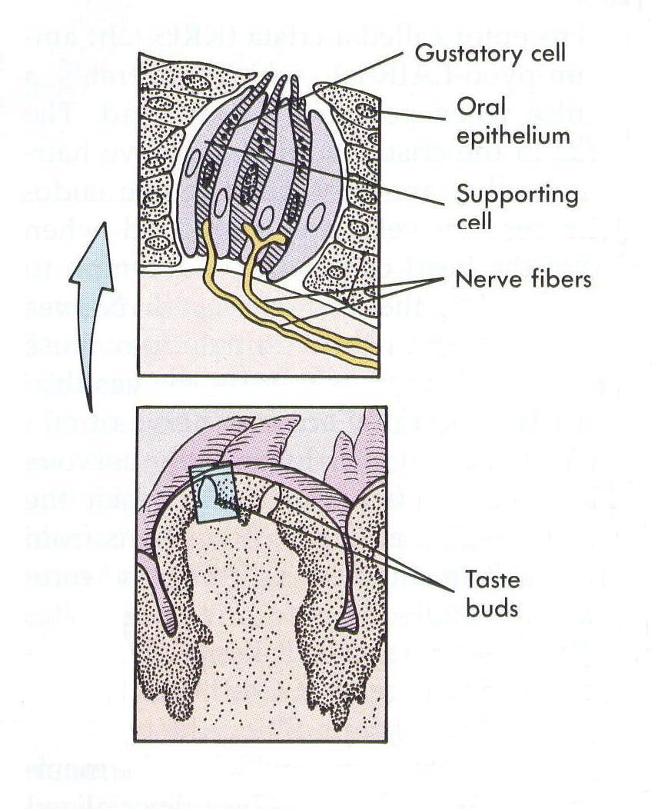
Taste and Smell – Chemical Receptors Taste buds
  - The mouth contains around 10,000 taste buds, most of which are located on and around the tiny bumps on your tongue. Every taste bud detects five primary tastes:
    - Sour
    - Sweet
    - Bitter
    - Salty
    - Umami - salts of certain acids (for example monosodium glutamate or MSG)
  - Each of your taste buds contains 50-100 specialised receptor cells.
  - Sticking out of every single one of these receptor cells is a tiny taste hair that checks out the food chemicals in your saliva.
  - When these taste hairs are stimulated, they send nerve impulses to your brain.
  - Each taste hair responds best to one of the five basic tastes.

Smell Receptors or Olfactory receptors
  - Humans able to detect thousands of different smells
  - Olfactory receptors occupy a stamp-sized area in the roof of the nasal cavity, the hollow space inside the nose
  - Tiny hairs, made of nerve fibers, dangle from all your olfactory receptors. They are covered with a layer of mucus.
  - If a smell, formed by chemicals in the air, dissolves in this mucus, the hairs absorb it and excite your olfactory receptors.
  - A few molecules are enough to activate these extremely sensitive receptors.
  - Olfactory Hairs easily fatigued so you do not notice smells
  - Linked to memories - when your olfactory receptors are stimulated, they transmit impulses to your brain and the pathway is directly connected to the limbic system - the part of your brain that deals with emotions so you usually either like or dislike a smell
  - Smells leave long-lasting impressions and are strongly linked to your memories

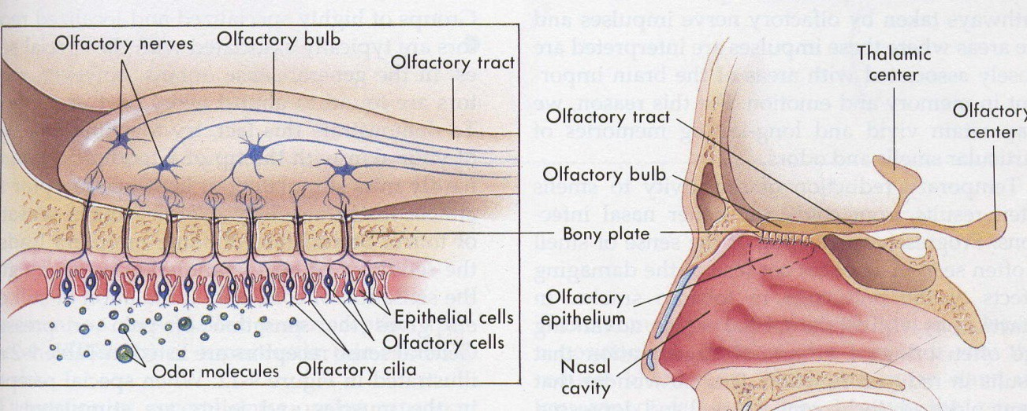
Much of what we associate as taste also involves smell – that is why hot foods “taste” different than “cold” foods

Skin receptors:

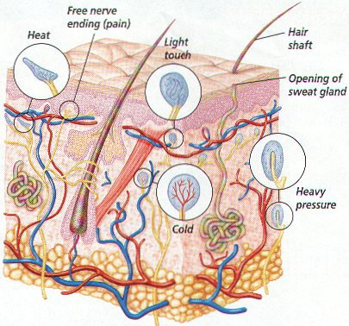
Your skin and deeper tissues contain millions of sensory receptors. Most of your touch receptors sit close to your skin's surface.

Light touch
  - Meissner's corpuscles are enclosed in a capsule of connective tissue
  - They react to light touch and are located in the skin of your palms, soles, lips, eyelids, external genitals and nipples
  - these areas of your body are particularly sensitive.

Heavy pressure
  - Paccinian corpuscules sense pressure and vibration changes deep in your skin.
  - Every square centimeter of your skin contains around 14 pressure receptors

Pain
  - skin receptors register pain
  - pain receptors are the most numerous
  - each square centimeter of your skin contains around 200 pain receptors

Temperature
  - skin receptors register warmth and cold
  - each square centimeter of your skin contains 6 receptors for cold and 1 receptor for warmth
  - Cold receptors start to perceive cold sensations when the surface of the skin drops below 95 º F. They are most stimulated when the surface of the skin is at 77 º F and are no longer stimulated when the surface of the skin drops below 41 º F. This is why your feet or hands start to go numb when they are submerged in icy water for a long period of time.
  - Hot receptors start to perceive hot sensations when the surface of the skin rises above 86 º F and are most stimulated at 113 º F. Beyond 113 º F, pain receptors take over to avoid damage being done to the skin and underlying tissues.
  - thermoreceptors are found all over the body, but cold receptors are found in greater density than heat receptors – most of the time of our environment is colder than our body temperature
  - The highest concentration of thermoreceptors can be found in the face and ears so your nose and ears always get colder faster than the rest of your body on a chilly winter day

Disorders of the Nervous System – symptoms, prevention, treatment
- Epilepsy - common and diverse set of chronic neurological disorders characterized by seizures.
- Seizures - the physical findings or changes in behavior that occur after an episode of abnormal electrical activity in the brain and are caused by abnormal electrical discharges in the brain
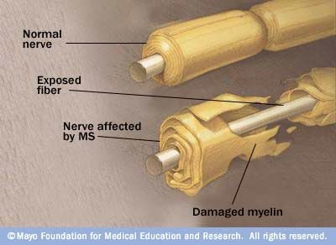
- Alzheimer’s Disease - a degenerative disease of the brain that causes dementia, which is a gradual loss of memory, judgment, and ability to function. - the most common form of dementia- affects an estimated 1 in 10 people over age 65
- Multiple Sclerosis - an autoimmune disease that affects the brain and spinal cord (central nervous system) - body's immune system eats away at the protective myelin sheath that covers the axons of the neurons and interferes with the communication - MS can affect vision, sensation, coordination, movement, and bladder and bowel control.
- Parkinson’s Disease - disorder of the brain that leads to shaking (tremors) and difficulty with walking, movement, and coordination. People with Parkinson's disease have low brain dopamine concentrations.
- Shingles (herpes zoster) - painful, blistering skin rash due to the varicella-zoster virus, the virus that causes chickenpox – the virus remains inactive (becomes dormant) in certain nerves in the body. Shingles occurs after the virus becomes active again
- Cerebral Palsy - group of disorders that can involve brain and nervous system functions such as movement, learning, hearing, seeing, and thinking resulting from damage to certain parts of the developing brain
- Glaucoma - a group of eye conditions that lead to damage to the optic nerve due to increased pressure in the eye - the eye’s drainage system becomes clogged so the intraocular fluid cannot drain and as the fluid builds up, it causes pressure to build within the eye. High pressure damages the sensitive optic nerve.
- Pink eye (Conjunctivitis) – infection of the conjunctiva of the eye

Effects of Drugs on the Nervous System
- Alcohol - central nervous system depressant – cell membranes are highly permeable to alcohol so once in the bloodstream it can diffuse into almost all body tissues. It is absorbed in the stomach so it gets into the blood stream quickly and slows down function of the nervous system
- Caffeine - acts as a central nervous system stimulant - caffeine suppresses melatonin for up to 10 hours and also promotes adrenalin. Melatonin is strongly associated with quality sleep, while adrenalin is the neurotransmitter associated with alertness.
- Nicotine - small doses of nicotine have a stimulating action on the central nervous system – it is highly addictive nicotine's effects on the brain cause an increased release of neurotransmitters associated with pleasure. The brain quickly adjusts to repeated nicotine consumption by decreasing the amount of neurotransmitters released. The effect of this increased tolerance is that the smoker must continue to use nicotine in order to avoid the feelings of discomfort associated with withdrawal from the drug. Irritability and anxiety often ensue during nicotine withdrawal.
- Marijuana - THC, the main active ingredient in marijuana, binds to membranes of nerve cells in the central nervous system that have protein receptors. After binding to nerve cells, THC initiates a chemical reaction that produces the various effects of marijuana use. One of the effects is suppression of memory and learning centers (called the hippocampus) in the brain.

